Digital Hero Role Description

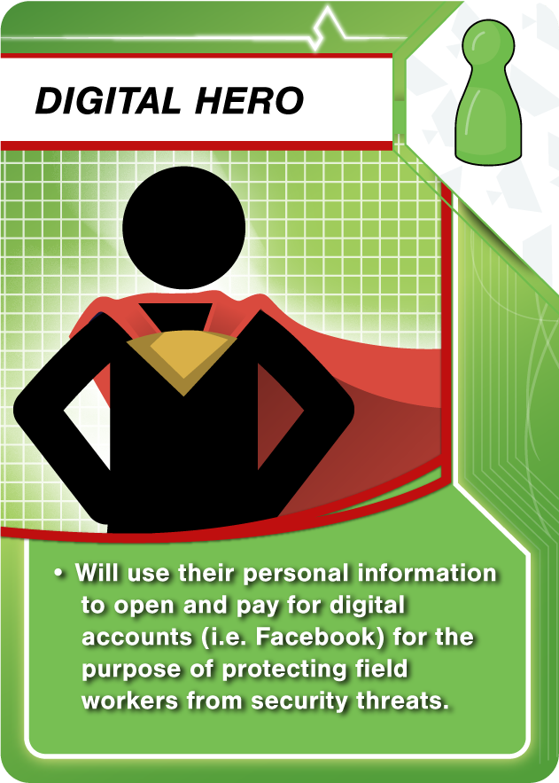
Vision:

We are actively working on a new ministry strategy called Media to Disciple Making Movements (M2DMM). M2DMM is all about taking full advantage of the widespread use of the internet to cast a huge net of evangelism in order to: share the Good News, find people of peace, and connect them to on-the-ground “fishers of men” who are practicing “DMM” principles.

Purpose:

We need someone to fill the Digital Hero role for the following reasons:
- This role will help us to be efficient, effective, and to maintain our longevity for living in country.
- Someone needs to sign up for numerous online accounts to pursue an M2DMM ministry strategy
- Someone needs to provide payment details for online services and advertisements
- Because we live in-country, we have certain limitations with opening accounts and keeping those accounts securely separated from our names. If we ran all related accounts through our personal names, it could get us kicked out of the country in a hurry and become a security issue for our families and us.
- There is an element of risk—security-wise—for the person who signs-up for this role and these accounts, but it is at a much different level since they are far removed from the place and people where the work is being done. (See security section)

Values:

Ideally, the candidate would have the following values:
- A value for obeying the Great Commission (Matthew 28:18-20)
- A value for service and sacrifice so that others may know the truth (Romans 12:1-2)
- A value for consistency, excellence, and responsive communication (Colossians 3:23)
- A value for balancing security concerns with the “worth-it-ness” of our mission as believers (Matthew 5:10-12)
- A value for flexibility and helpfulness as things can often change and bend as they progress (Ephesians 4:2)
Description of Role:

- Allow us to set up an initial or additional personal Facebook account in your name and provide us with a copy of your driver’s license in case Facebook asks us for identity verification some day
- Work with us to find a financial solution that is flexible for use as needed for an M2DMM strategy, yet gives you confidence in relation to any risks or decisions made.
- Be generally available if issues come up and we need to verify something that is in your name, and/or providing us some personal information so that we can verify accounts without bothering you (we expect this to be only occasional, but will rely of responsive communication when it happens)
- Operating on the Internet with an awareness of security. For people living here, we typically Google-search our names and take down anything that would connect us to Church Planting activity. We also make sure our social media accounts are private so that only friends can view them. We aren’t trying to hide ourselves from the Internet publicly; we’re just trying to avoid connecting ourselves to Church Planting activity online. We would recommend doing something similar.
- One Time Need: Physically go to a UPS Store and open up a mailbox in your name that can be used as the billing mailing address for online accounts.

Security:

As mentioned, there is some security risk involved in this role. If someone were to become overly upset with what we’re doing (buying ads that introduce people to Good News and operating an Facebook page that posts daily content about Jesus), they might want to find out who is behind it and target that person in some way. Only Facebook administrators can see who is behind a Facebook Page. The general public cannot unless someone is extremely good at hacking. It’s very unlikely that anything would happen, but we want to take the necessary precautions from the beginning to make sure the work and the people involved are protected. Whatever risk there is, we see it as worth it. (See values section)

Commitment:

We are asking for a minimum 5-year commitment to this role. This is a critical part of what we are building, and we have the need to be able to rely on the person who fills it to be consistent and a good communicator. We would like to request that anyone considering this role will count the cost ahead of time and make a commitment with an understanding of that cost. We very much would see the Digital Hero as a key partner, whose work is incredibly valuable and will greatly impact the nations.

