Phone Interactions

From the very first interactions with a contact we want to remain focused on the end goal: to multiply multiplying disciples through discovering, sharing, and obeying God. In step with the Spectrum Tool (below), there are key areas of life and faith that we want to be shaping from the first phone calls and visits. With this in mind, we know we will be continually tweaking and improving how to interact with contacts. Every conversation is different and every individual is different.

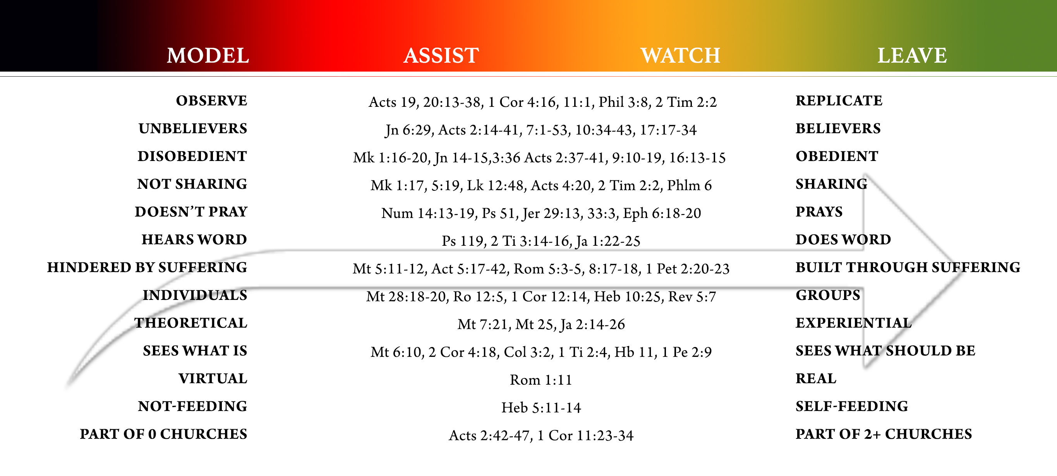
Helpful Tips:
- Pray.
- Determine your primary goal(s) in making a phone call (e.g. confirm their identity and interest, assess their understanding, set up a meeting). [The current nature of the follow-up system may influence your goal(s), depending on how much information you already have and what filters are in place before making a phone call.]
- Ensure that you are using a phone and SIM card that are not linked to your identity (see “New Partner Intro” document for more details).
- Consider your lead-in statement based upon your context, security concerns, and what the contact has already shared about their interest. For example: “Hi, someone gave me your number. I was told that you were interested in a Book (or talking to someone about JC/spiritual things).” [Be vague about your personal connection to any website and avoid naming a specific website on the phone or in a text, if possible.]
- After your lead-in statement, let the contact respond. Give them an opportunity to share about their spiritual journey or why they made contact. This will give insight into what they are seeking, how hungry they are, how much they understand, and what obstacles are in the way.
- Inquire about others.
  - “Are there other people you know who are interested in this?”
  - “Do you have any friends/classmates/co-workers/family members who are open to having spiritual conversations?”
  - If they want to meet, then ask them if there are others who could come to the meeting. [“It’s okay if they aren’t yet where you are on their spiritual journey, but are they open to searching for truth with you?”]
When the contact asks spiritual questions, instead of simply trying to answer their question(s), considering a different response:
- “Wow, God is clearly working in your life, you are asking some hard/great questions.”
- “I can answer that question for you, but it probably won’t satisfy you (or be sufficient) because you do not yet understand the big picture of the Chr faith.”
- “You are looking for truth. That’s great. The answers you are looking for are in the Book. If you’re interested, I am willing to help you learn how to find the answers you are looking for.”

“You will seek me and find me when you seek me with all your heart.”
— Jeremiah 29:13

Consider ways of appropriately discerning their hunger and willingness to seek truth with all their heart.
- Are they willing to come to you for a meeting? [Note: Though riskier, sometimes workers prefer to let the seeker determine when/where to meet in order to eliminate unnecessary hindrances (e.g. fear, inability to travel) for the first face-to-face meeting(s).]
- As phone conversations continue, is the seeker willing to call you, thereby expressing initiative and willingness to spend their own money on calls/texts.
- Perhaps one of the biggest filters that reveals genuine hunger is whether or not they are in the Word (a lot)—i.e. reading, listening, memorizing, obeying, sharing.

Other tips:
- Consider the implications of using your real name versus a pseudonym.
- Be prepared to communicate your work/identity (simple tenable statement) and how you got their name and number if asked. [For example: “I work here and I’m a follower of JC. Someone gave me your name and number (keep it vague) and told me that you might like to learn about my faith journey (or read the Book, etc). If someone/a group really wants to learn to study the Book, I’m happy to help them get started (or to share about my own journey).”]
- Review the information they submitted as a way to guide the conversation, acknowledging that asking them questions (even if you already think you know their responses) is perhaps the most productive way to lead the conversation, verify their information, and build trust.
- If someone else in follow-up had prior phone contact with the seeker, ensure that the first person prepared for this “hand-off” by saying something like, “I have a friend who will call you. He is a foreigner and he speaks the local dialect/language.”
- In addition to assessing their hunger and understanding, it may also be helpful in the first phone call to determine the contact’s exact location, fear-level, family dynamics, and/or season of life (employed, studying, etc, which often reveals their age and availability). As noted above, discerning if they are alone on this journey is significant too, even as we encourage them to consider others who may be asking the same questions they have.
- The best way to become better at these calls is to do them. Go for it!

